**Assignment – Day 3**

import java.util.Scanner;

class Cab{

int fare;

int ud; // user distance

public Cab(){ //Default constructor

fare = 30; // Starting base fare on booking of a cab

}

public Cab(int amt){ //parameterized constructor

fare = amt;

}

void showFare(){

System.out.println("Total Fare: " + fare);

}

}

public class Cabdriver{

public static void main(String args[]){

int cd; //cab distance

Scanner sc = new Scanner(System.in);

System.out.println("Enter the distance of cab from user: ");

cd = sc.nextInt();

if (cd > 5){

Cab ob = new Cab(30 + 10 * (cd - 5));

System.out.println("Enter the user distance travelled: ");

ob.ud = sc.nextInt();

ob.fare = ob.fare + 10 * ob.ud; // (Parameterized constructor called)

ob.showFare();

}

else{

Cab ob = new Cab();

System.out.println("Enter the user distance travelled: ");

ob.ud = sc.nextInt();

ob.fare = ob.fare + 10 * ob.ud; // (Default constructor called)

ob.showFare();

}

}

}

Output:

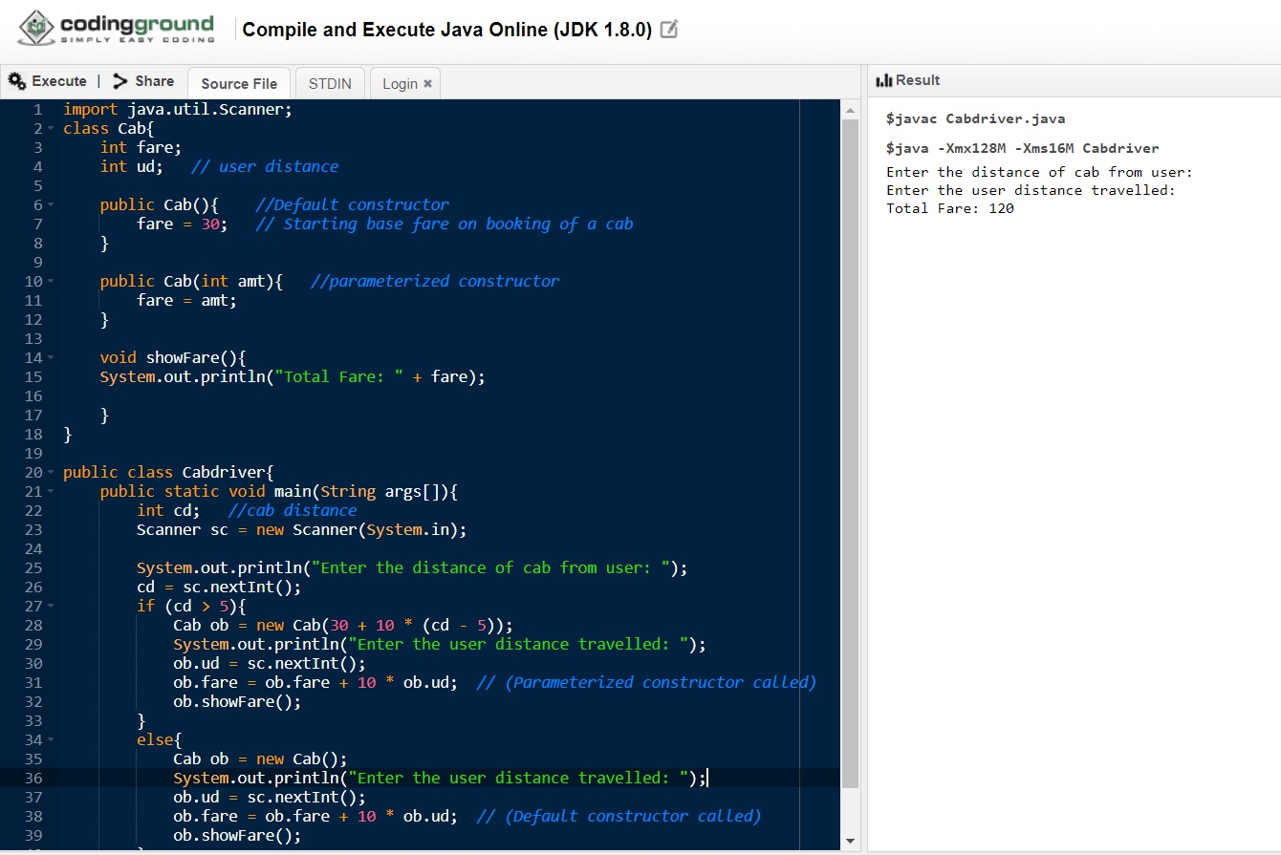

**Note:** Input is provided in STDIN column as mentioned below

***(Distance of Cab: 8km & User distance travelled: 6km)***